Tyngsborough Open Space and Recreation
Visioning Session
Please attend this important event and help identify the Town’s future open space and recreation needs and goals.

Make sure your voice is heard!

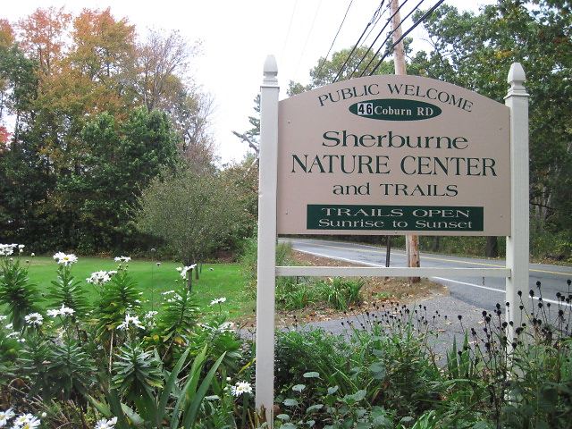
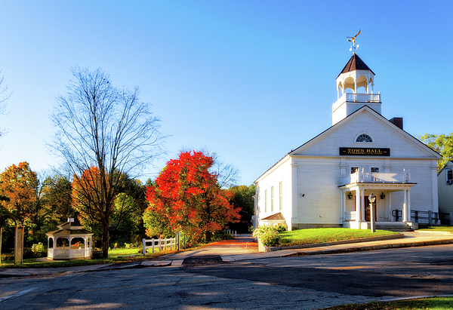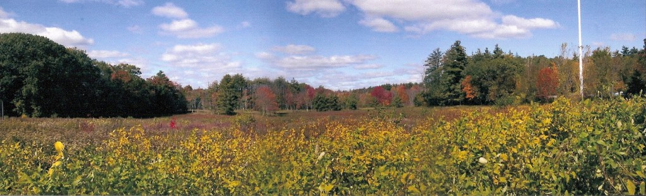

When: Monday, March 19, 2018
6:30 p.m. – 8:30 p.m.

Where: Town Hall
Community Room
25 Bryants Lane
Tyngsborough, MA

